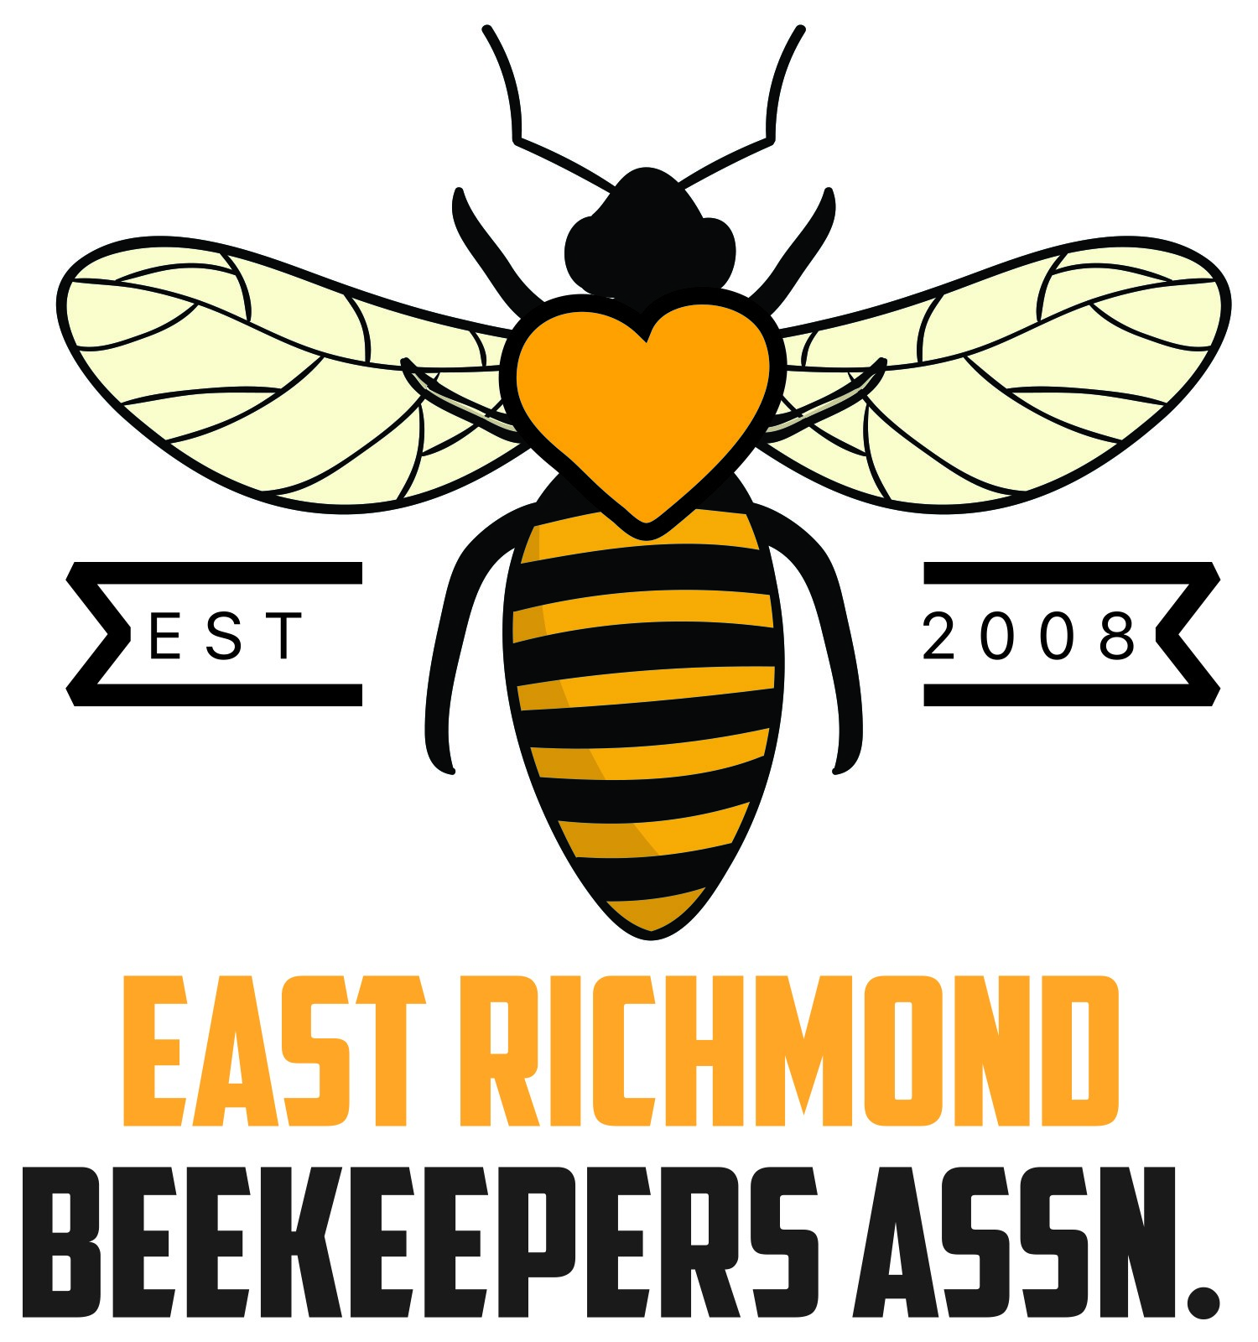
For the Love of Bees!
Intro to Beekeeping Classes
East Richmond Beekeepers Association (ERBA)

Class Sign-up and ERBA Membership Information Form
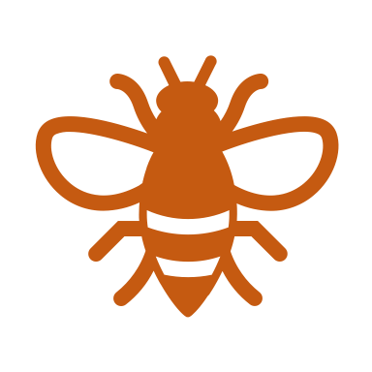
Location:
Fairfield Middle School
5121 Nine Mile Road
Richmond, VA 23223

Dates and Times:
Class 1: Saturday - March 9, 2024
Class 2: Saturday - July 20, 2024
Class 3: Saturday - October 19, 2024
Class 4: Saturday - February 22, 2025
All classes 9:00 a.m. to 4:00 p.m. (includes one hour lunch break)

Cost:
- $120 for All Classes* paid prior to first class. Fee includes latest edition of “Beekeeping for Dummies”
OR:
- $50 for Single Class* including “Beekeeping for Dummies” book
OR:
- $30 for Single Class* (book not included)
*All options include ERBA membership and annual dues for one year (a $10 value)

Please select your Participation/Payment Option
shown on next page

Welcome to the East Richmond Beekeepers Association!
Name
Street Address
City, State, Zip
Email address*
Phone No
XXX•YYY•ZZZZ

Our membership year is from July 1 to June 30 and dues are not pro-rated. Dues are $10 for an individual or $15 for a family. Each membership gets one vote in club decisions.

ADDITIONAL BENEFITS!! Membership also entitles you to substantial discounts off subscription rates to national bee publications -American Bee Journal, Bee Culture and the Speedy Bee, and so much more. When you subscribe, just designate you are a member of the East Richmond Beekeepers Association. *We will mail club correspondence to your email address unless you specify otherwise.

Intro To Beekeeping Class(es) Participation and Payment Options

Class Participation Option Selected and Amount Paid
☐$120 for all 4 classes. Fee includes “Beekeeping for Dummies” Book
☐$50 for single class only. Includes “Beekeeping for Dummies” Book
☐$30 for single class only. Book not included.

Please make check payable to: ERBA
Amount Enclosed $______
Checks and this sheet can be mailed to:
ERBA
C/O Club Treasurer
P.O. Box 325
Sandston, VA 23150

Please answer the following questions to make the best of your ERBA membership:
Are you currently a Beekeeper? _____ Yes ______ Not Yet
If YES, how long? ___ Less than a year ___ 1 Full Year ___ 2-5 Years ___ 5 Years or More
How many hives now? _____ Highest number of hives you had at one time? _______
If you are a member of other clubs, which clubs? __________________________________
WE HAVE JOBS & ACTIVITIES THAT NEED YOUR HELP. PLEASE CHECK THOSE OF INTEREST TO YOU.
 | Help with Social Media (Facebook, Twitter) |  | Work at the State Fair Beekeepers booth
 | Help with the ERBA Website |  | Plan club meeting presentations
 | Teach a beekeeping class |  | Serve as an ERBA officer
 | Want to become a Master Beekeeper |  | Bring meeting refreshments
 | Anything else to help fellow ERBA members?
MENTORING OPPORTUNITIES
I’m experienced, and willing to answer member questions by email or FaceBook™
I’d like to join a small group to share learning about (name your topic)
I’m brand new to beekeeping and would like a one-on-one mentor or buddy to help

Questions? email: EastRichmondBees@gmail.com

